6A^{th} Grade: Unit 1, Lesson 3

- Write the addition expression that is represented by the area model.
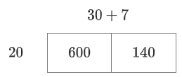
$$600+140$$

- Write the multiplication expression that is represented by the area model.

$$37 ×20$$

- What is the sum of the products of $7×10$ and $7×4$?
98

- What are all the common factors of 36 and 54?

2,6,9, and 18

- The number 60 can be represented by the product of 5 and what other number?

12

- Explain whether $54=6(7+2)$ is true or false.

This is equation is true because the quantity 7+2 has a value of 9 and the product of 9 ang 6 is 54. Therefore 54=54, making the equation true. This can also be determined by find the sum of the product of 6 times 7 and 6 times 2, which is also 54.

